Work Site / Customer | Machine type / details / ID Number
COMMISSIONING AND WEEKLY INSPECTION OF THE MEWP
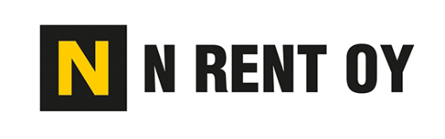
Target of inspection | OK | Failure / Missing | Fixed
Operating and Maintenance instructions, warning signs (exist)
Lift mounted/erected according to instructions
Lift position levelled and in balance
Outriggers in support position (functionality)
Operating ground bearing capacity ensured
Emergency stop, auxiliary power (functionality)
Control equipment (functionality)
Warning signal and light indicators (functionality)
Visibility of lift (warning lights and other indicators)
Worktop fall protection, operators wear safety harness (if required)
Maximum load limits (functionality)
Limit switches, brakes (functionality)
Oil leakages, other visible damages or other notices
Workplatform stabilizing equipment
No electric wires or other avoidable obsticles close to operation area, ground level uniquality checked
Routes / Operation area checked
Operation Plan (if required)
Approvals of other inspections checked (inspection plate and documents)
All operators has passed operating scooling/education
Daily operating tests agreed
Other:

Date |  |  | Author / Inspector(s)
Please, send signed Inspection Form to your immediate supervisor and a copy by email to:tilaukset@nostinrent.fi
www.nrent.fi

